# Economic & Environmental Aspects of Biofuels

Ravi N Vikas E

Dept of Electrical & electronics Dept of Electrical and Electronics

The National Institute of Engineering The National Institute Of Engineering

Mysuru, Karnataka, India Mysuru, Karnataka, India

[nravim7@gmail.com](mailto:nravim7@gmail.com) [vikaseshwarappa@gmail.com](mailto:vikaseshwarappa@gmail.com)

4NI19EE082 4NI19EE118

# Abstract—

The economic motivation for biofuels is that they are a convenient, low-cost,

domestically producible substitute for oil, a fuel that is getting costlier by the day and is

also imported from politically volatile regions. The increased demand for agriculture

from biofuels can also address the worldwide problem of declining farm income. But

negative effects on food and the environment are threatening to offset the positive effects

on welfare as an energy source. This, however, should not be surprising. As the previous

chapter explained, biofuels are intensive in the use of inputs, which include land, water,

crops, and fossil energy, all of which have opportunity cost. Understanding how biofuels

will affect resource allocation, energy and food prices, technology adoption, and income

distribution, etc., is essential at this very early stage of development. A variety of

economic modelling techniques are being used to model the impacts from different

angles. Microlevel models like cost accounting models and models of technology

adoption and resource allocation are useful for calculating the economics of biofuels from

the perspective of an individual economic agent. Sector models, general equilibrium, and

international trade models on the other hand are useful for studying the aggregate impacts

of biofuels. But nonmarket effects like the impact on the informal economy, which is

important in developing countries, and environmental spill overs like loss of natural

habitats as a result of agricultural expansion are unlikely to be captured in standard

neoclassical approaches and new techniques will be needed here

# Introduction

Critical Analysis of the First-Generation Biofuels The first environmental assessment studies of the first-generation biofuels show a positive energy balance (energy produced is about twice as much than the energy consumed) and a potential for reducing the greenhouse gases that is considerable (Ometto et al. 2009). The authors also concluded that the fuel ethanol life cycle is responsible for the consumption of a

high quantity and diversity of non-renewable resources. These resources are linked to the mechanization level of the rural activities, the intensive use of pesticides, fertilizers, and diesel. The ethanol life cycle process is also responsible to negative and adverse impacts at the local and regional scale such as ozone formation, acidification, ecotoxicity, and human tox icity. The main causes for these impacts are the use of fertilizers and the burning after harvest that is in the case of the first-generation ethanol traditionally realized to cogenerate electricity during the process. Similarly, Querini (2012) has found distributed environmental consequences for the first-generation biofuels. These impacts are broken down by their origins in the production cycle of biodiesel from sunflower and first- generation ethanol from wheat. They are presented on Fig. 3 and globally compared to other fuels for the transportation sector in Table 2. In particular, whatever the feedstock being considered, the agricultural practices are responsive for a significant part of

these production impacts. Depending on the good agricultural practices, even the global warming potential is in favor of fossil fuels. Ethanol from sugarcane is confirmed as the most environmental-friendly biofuel for the first-generation. Figure 4 represents the global warming potential for different fuels in a Wellto-Wheel life cycle assessment analysis (Querini 2012). The environmental impacts of fossil fuels occur for a small part during the extraction and refining processes and essentially during the usage phase. Biofuels are characterized by their double distributed environmental impacts: (i) throughout the production chain of the added value, (ii) in most of the environmental compartments considered by the major life cycle assessment methodologies. The question of the good agricultural practices, the sustainable management of land, water, and fertilizers inputs as well as the processing technologies and the final use of the produced resource becomes the central issue. In this context, the economic and ecological performances from one biofuel to another are fundamentally challenged. However, some initiatives are gradually introduced in order to provide sustainability certifications to the most environmentally virtuous biofuels, such as the guideline to evaluate the sustain ability performances of biofuels published by the Natural Resources

Defense Council (NRDC 2014).

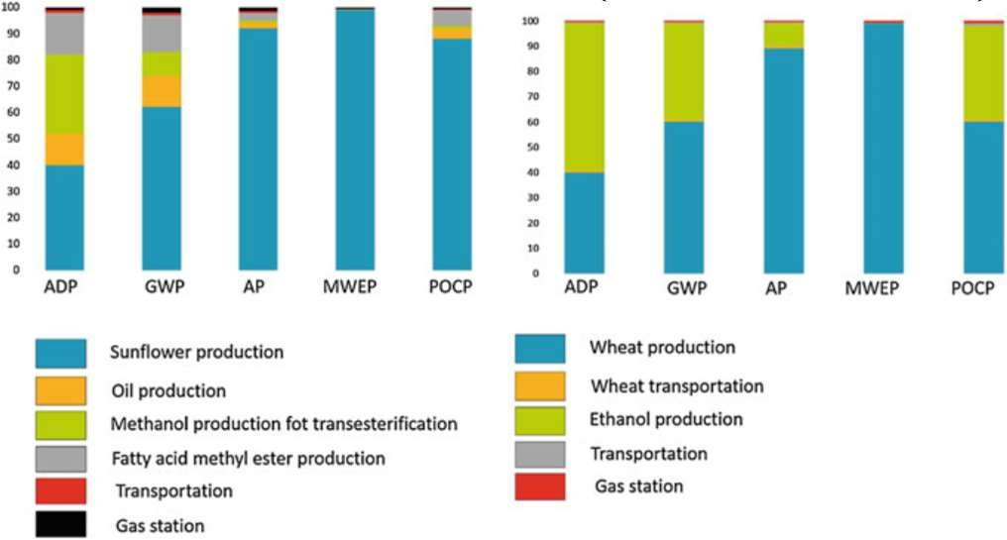

New Investments in Renewable

Energies

The new investments in capacity in renewable energy according to the Renewable Energy Network (REN21 2015) are depicted Fig. 6. Since the economic crisis in 2008, these investments are being reequilibrated between developed, which investments started to stagnate, and developing countries in which the investments remain steadily growing (Fig. 6 left). The sectorial breakdown per sector, as well as the net growth for 2014 in comparison to 2013 [Fig. 6 (right)] clearly show that this redistribution is beneficial for the wind- and solar- electricity sectors but not for the biomass and biofuel sectors. Drivers for these redistributions of funding are to search among the criticism that arise against the first-generation biofuel, and in particular, the fuel versus food debate that reached its paroxysm in 2008. In this context, the biofuel support polices remain under review in the United States and Europe. According to Timilsina and Shresta (2014), the investments for biofuel refineries were approximately 16 billion US$ in 2008 and suffered a threefold drop to 6.8 Fig. 6 Global investments in renewable energy from 2004 to 2014 (left) and sectorial ventilation in 2014. Growth represents the variation in investments from 2013 to 2014. Adapted from REN21 (2015) Economic and Environmental

Aspects of Biofuels 537 billion in 2011, and even 5 billion in 2012. In this period, many of the 650ethanol plants worldwide were operating below their theoretical capacity while others experienced temporary closed down because of the very high volatility of the prices, the fluctuating demand and the many reserves that has been made on firstgeneration ethanol. Brazil had the capacity to produce approximately 37 billion liters (860 PJ) in more than 440 plants in 2012. However, because of the specificity of the feedstock used, sugarcane that has a short storage life, Brazil has an excess of 30 % in sugarcane milling capacity and the production facilities are generally oversized. In reality, the production reached 26 billion liters (610 PJ). As the United States are primarily using corn, which as a longer shelf-life, the USA with approximately 210 ethanol plants had the capacity to produce 56 billion liters (1310 PJ) in 2012. Therefore, US plants have on average about three times the annual capacity of Brazilian plants. Feedstock differentiation and implementation of integrated first- and second- generation’s bioethanol refineries might be an opportunity for the existing Brazilian facilities (Dias et al. 2013). The European Commission has already proposed to limit the proportion of biofuels from the first-generation biofuel used for the transportation sector to 5 % and to remove the subsidies for food crop-based biofuels by 2020 (Timilsina and Shresta 2014). If these commitments are confirmed, the secondgeneration biofuels are expected to produce the other 5 % in volume within the next five years in the European Union. Thus, once the last technological and economic uncertainties are controlled, investments at the industrial scale should be on the raise again.

Future Challenges to Improve the

Environmental Balances of Biofuels

Figure 7 (top) presents the greenhouse gases reduction potential for different feedstock of firstgeneration. These effects are further amplified with better yields per hectare. In the case of secondgeneration Miscanthus x giganteus, Arundo donax, and Pennisetum purpureum seem the most promising feedstock for achieving high-energy yields (Laurent et al. 2015). Unfortunately, there is neither ideal feedstock nor universal process for the biofuel production process and the performances are dependent on the good adequacy between the feedstock properties and the whole process. In the case of second-generation fuels, the pre-treatment step is of particular importance. For instance, depending on the composition of the plant cell wall and in particular the amount of ramifications on the polysaccharides fractions, either the dilute acidic pre-treatment for wheat straw or the ammonia fiber expansion for corn stover (Wyman et al. 2005) will perform best (Fig. 7, bottom). Furthermore, in the situation of intensive farming, a high input of nitrogen fertilizer might lead to adverse effects. In fact, ammonia is produced with the Haber reaction at 200–400 bars and 450 °C in the reaction of the nitrogen from air and natural gas. This is both a high energetic costly process and part of the explanation on the relationship between fossil fuels and food crops prices (Esmaeili and Shokoohi 2011).

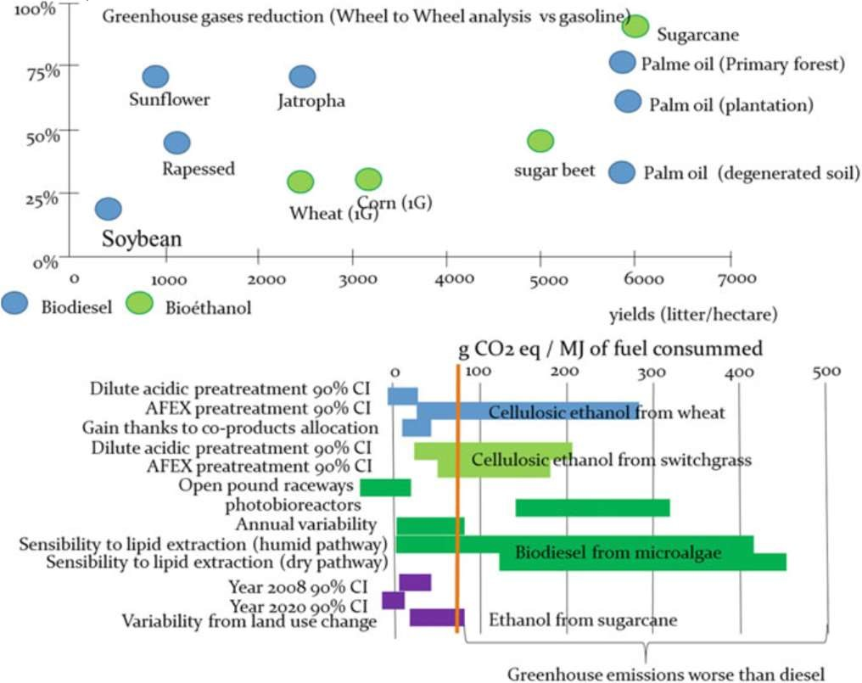

Fig. 7 Comparative assessment of the greenhouse gases reduction potential according to the type of feedstock used (top) and to the type of pretreatment and amelioration potential of the existing technologies. AFEX stands for ammonia fiber expansion. Data compiled from Maurya et al.

(2015), Mafe et al. (2015) and Pandey et al.

(2014).



Fig.8 Share of renewables in global energy supply (IEA 2006)

# Conclusion

Biofuels production processes, whatever the generation, are at the center of industrial ecology principles. In this context, the development of integrated bio refineries combining the best of the first, second, and third-generation processes in one same geographical unit is a promising line to work on. However, even an ideally environmental friendly energy resource, though large investments and governmental subsidies may have negative indirect effects. This leads to a drop in the prices of fossil resources and makes them even more attractive and used in other parts of the planet. Without any regulation, these financials mechanisms have the side effect of making the efforts obsolete and even counter productive, at least on the global environmental indicators, such as the emissions of greenhouse gases. Therefore, in the absence financial regulatory, the large-scale development of “green fuels” will be just another additional energy to support the global economic activity and never a real alternative associated with the energetic transition. To conclude, the environmental impact of the production of biofuels cannot be tackled without a transparent and standardized collaboration of all stakeholders. They have a common interest to join forces in a holistic research approach that has to be necessarily conducted in a transdisciplinary approach, and not dictated by the sole economic aspects. The development of the biorefinery lies now at a crossroad. It must be refocused on the territorial aspects, especially with the agricultural and forestry sector. It is mandatory to evaluate the actual environmental impacts in terms of waste generation, raw material consumption and regeneration, water availability, and waste recycling processes. This must be done in relation with a geographical context, including all socioeconomic backgrounds, resources

avail ability, and short-range markets possibilities. But the virtuous modes of energy generation for the future remain largely to be reinvented.

References

Economic and Environmental Aspects of Biofuels Emmanuel Bertrand, Marilys Pradel and ClaudeGilles Dussap.

Aden A, Foust T (2009) Techno economic analysis of the dilute sulphuric acid and enzymatic hydrolysis process for the conversion of corn stover to ethanol. Cellulose 16(4):535–545

Alghur OF, Kadioglu A (1992) The effects of vinasse on the growth, biomass and primary productivity in pea (Pisum sativum) and sunflower (Helianthus anus).

Agric Ecosyst Environ 39(3,4):139–144 Barbosa MJ, Wijffels RH (2013) Biofuels from microalgae.

In: Richmond A, Hu Q (eds) Handbook of microalgal culture, applied phycology and biotechnology, 2nd edn. Wiley, Hoboken, pp 566–577

Carbajal’s-Dale M, Barnhart CJ, Benson SM (2014) Can we afford storage? A dynamic net energy analysis of renewable electricity generation supported by energy storage.

Energy Environ Sci 7 (5):1538– 1544 Cha KS, Bae JS (2011) Dynamic impacts of high oil prices on the bioethanol and feedstock markets. Energy Policy 39(2):753–760

Chiaramonti D, Prussi M, Ferrero S et al (2012) Review of pretreatment processes for lignocellulosic ethanol production, and development of an innovative method. Biomass Bioenergy 46:25–35

Appendix: Definition of Terms

**Renewable energy**: Energy derived from resources that can either cannot be depleted or

can be regenerated.

**Fossil energy**: Energy derived from sources like coal and petroleum (crude oil and

natural gas), which are formed from the fossilized remains of dead plants and animals

over millions of years.

**Biomass**: Plant matter that can be used as fuel or for other commercial and industrial

uses. The source of biomass can either be purpose-grown crops or crop wastes and

residues, which are generated by agricultural or forestry activities.

**Bioenergy**: Energy derived from biomass.

**Biofuel**: Fuels derived from biomass, which can be in solid, liquid or gaseous states. In

our context it is taken to refer to liquid or gaseous transportation fuel derived from

biomass.